**Common problems of Intelligent Windmill**

1. **The code can not be burned**

The reason why the code cannot be burned is probably that the Bluetooth switch is turned on, and the Bluetooth is also connected to the serial port Tx,Rx, which will affect the program burning. If the Bluetooth switch is turned off, the program can be successfully burned.

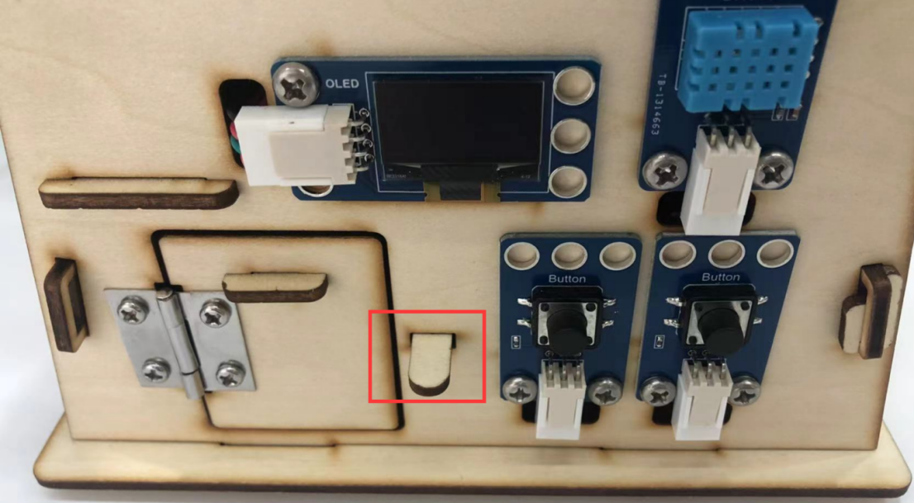

1. **Bluetooth APP fails to control Intelligent Windmill**
2. Burn the code of Bluetooth control.
3. Bluetooth is not turned on.

Drag the connecting rod outward to open the Bluetooth, as shown in the figure below.

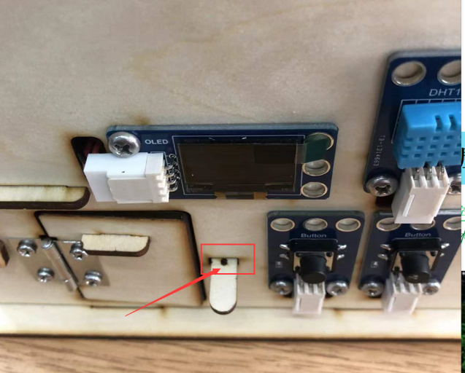

1. **Some parts are broken**

If some parts are accidentally broken, they can be bonded with super glue.